Scaling Techniques Documentation

1. Objective

To put specific numerical features on a similar scale, feature scaling was employed. This is crucial for machine learning methods, especially K-Means clustering, that are sensitive to variations in feature ranges.

2. Scaling Technique: StandardScaler

StandardScaler from Scikit-learn is used in the project.

By deducting the mean and dividing the result by the standard deviation, StandardScaler standardizes a numerical property.

The formula is:
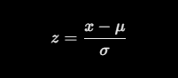

Where:
- x = original value
- μ = mean of the feature
- 𝝈 = standard deviation of the feature
- z = standardised value

The mean and standard deviation of the modified training features are often close to 0 and 1, respectively.

3. Features Scaled

The following numerical features were selected:

- SeniorCitizen
- tenure
- MonthlyCharges

Categorical features were encoded separately using one-hot encoding.

4. Implementation

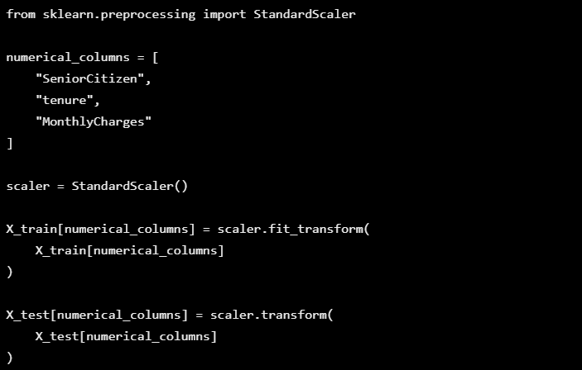

5. Avoiding Data Leakage

Before scaling, the dataset was divided into training and testing sets.

Only the training set was used to fit the scaler. The testing data was then transformed using the same fitted scaler.

This keeps the scaling parameters used during model training from being influenced by information from the testing data.

6. Relevance to the Models

K-Means Clustering

K-Means groups comparable customers based on distances. Scaling aids in preventing the dominance of features with wider numerical ranges in distance computations.

Artificial Neural Network

By supplying numerical inputs on similar scales, scaling can aid in neural network training.

